ITCS 1010 Programming Logic

Logic Plan 7 – Chapter 7 – 20 points

“Lottery Numbers Using an Array to Hold a List of Random Lottery Numbers and
Totaling the values in the Array”

Student Name ___________Steven Woodard________________

Given the following problem statements, perform the steps and answer the questions listed below, which are designed to help you analyze the problem and prepare a strategy for solving the problem. Submit this logic plan and C# Project into a folder, zip the folder, and submit in Blackboard for grading.

Problem statement: Revise the application created in Tutorial 7-1 to accumulate all 5 values in the array. Show the accumulated values from the array in an output label control.

For example: Total = (Total + lotteryNumbers [index])
or
Total += lotteryNumbers[index]

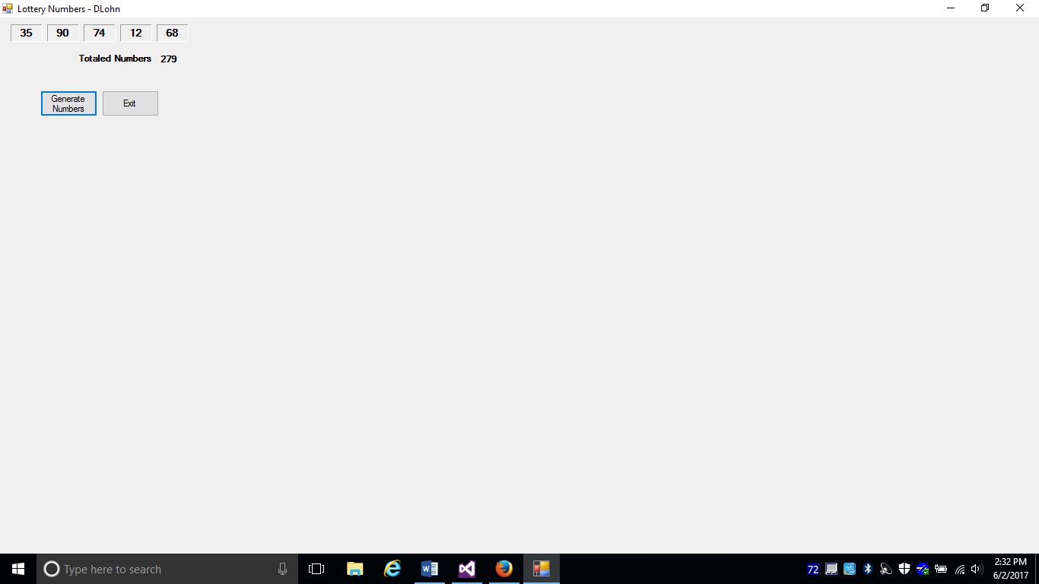

Use label controls, button controls, and program comments where applicable. Make sure the C# program is free of syntax and logic errors. Also, include user-friendly ToolTips on button controls.

First: Create a file folder on your USB Port drive or hard drive at home, and call it “Logic Plan7 Your student name”.
For example “Logic Plan7 DLohn”.

Second: There is no VideoNote associated with this Lab.

Third: Create the Logic Plan!

Design the Program’s Logic: enter your answers in the IPO chart below. Write pseudocode and insert below. Draw a flowchart and insert below.

What must the user enter as INPUT?
INPUT
Left click the Generate Numbers button

How will the program generate the 5 random numbers as output?
PROCESSING
FOR loop fills the array with 5 random numbers in the range 0 through 99 Testing: FOR int index = 0 and index < lotteryNumbers.length Fill the Array with 5 random numbers lotteryNumers[index] = rand.Next(100)

Fun fact:
The process leverage the for loop to add up all of the numbers

What OUTPUT will the program display?
OUTPUT
Display 5 random numbers in 5 label controls
+
The sum of the random numbers.

ENTER PSEUDOCODE HERE the pseudocode you wrote below in this Word document for grading.

generateButton_Click handler
1. Declare a Label array variable called “labels”
2. Declare numeric variable int, an Integer which declares the size needed for the array given the number of labels that are not a specific label.
3. Declare an int array named lotteryNumbers with respective number of elements via the method of creatingArrayForLotteryNumbers
4. Run PutRandomNumsInLottery method to put random numbers into the lotteryNumbers array, passing the reference to the lottery numbers
5. Run DisplayLotteryNumbers method with the lotteryNumbers array and “labels” array to display the lottery numbers

CreatingArrayForLotteryNumbers method
1. return new array of int with numOfLotteryNumbers as the length

PutRandomNumbsInLottery method
1. Declare an int (myAccum) for the accumulator
2. Declare a random object, referenced by a variable named rand.
3. FOR loop uses an int variable named index as its counter. Index variable is initialized to 0 and incremented by 1 after each loop iteration. Loop will iterate as long as index is < the lotteryNumbers.Length. Get a random number in the range 0 through 99 and assign it to lotteryNumbers[index].
…
Add the current iteration of lotteryNumbers[index] to the accumulator variable myAccum
4. Push sum in myAccum to display

DisplayLotteryNumbers method
1. Display the 5 label controls as output.

Click_ExitButton Event
- Left click the Exit button to Close the form.

DRAW OR COPY/PASTE FLOWCHART HERE the flowchart you designed below in this Word document for grading:

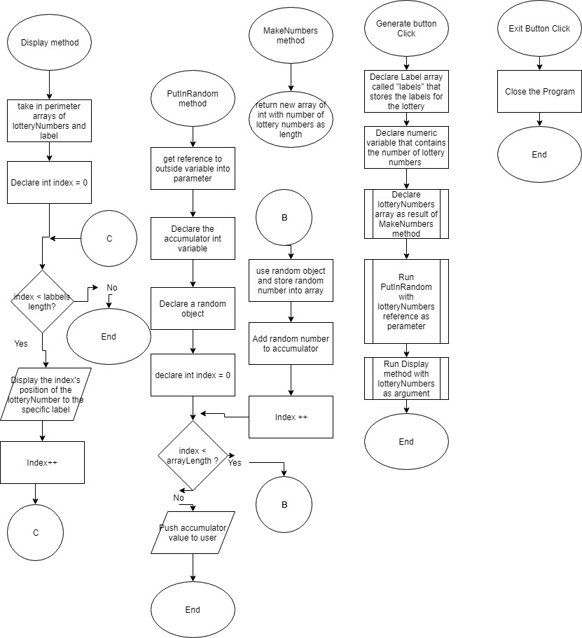

Fourth: Complete the programming problem.

Save this project as “ Tutorial 7-1 your student name”, for example “ Tutotorial 7-1 Dlohn”, in your “Logic Plan 7 your student name” file folder and submit in this category for grading.

